ASSIGNMENT-IICT 4
Counting techniques and Math in CS

Math in CS
Q1: How would you think math is playing role of backbone in CS? Mention some references other than slides. (5-7 lines only)
Q2: How smart devices calculate blood pressure, explain with mathematical formula. Give at least five examples with 2 to 3-line descriptions of those smart devices.
Q3 : consider the following graph and
i. Draw adjacency list
ii. draw adjacency matrix
a.
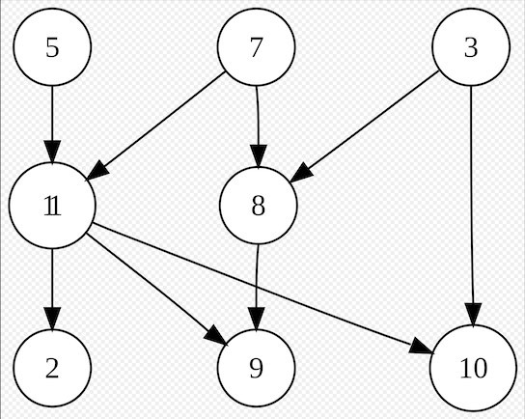
b.
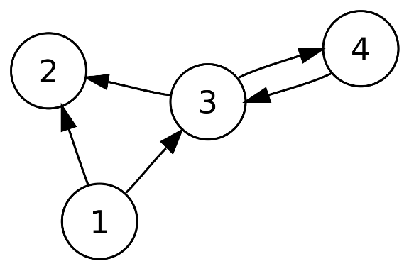

c.

Q4: Consider the following adjacency matrix draw a graph also show the this is directed or undirected graph
a.
 | A | B | C | D | E
A | 1 | 1 | 0 | 0 | 1
B | 1 | 0 | 0 | 1 | 0
C | 0 | 0 | 1 | 0 | 1
D | 0 | 1 | 0 | 1 | 0
E | 1 | 0 | 1 | 0 | 0

B.
 | A | B | C | D | E
A | 0 | 1 | 0 | 0 | 0
B | 0 | 0 | 0 | 1 | 1
C | 0 | 0 | 0 | 0 | 0
D | 0 | 0 | 1 | 1 | 0
E | 0 | 0 | 0 | 0 | 0
COUNTING TECHNIQUES

1. How many 3-digit numbers can you make using the digits 1, 2 and 3 without repetitions?
2. You have 4 T-shirts, 2 Jeans, 6 Sarees, 5 Formal Shoes and 3 Cowboy boots. In how many ways can you decide what to wear?
3. You have 50 students in a class, and you must select three out those for the posts of President, Vice-President, and General Secretary. In how many ways can you do that?
4. How many different words can we make using the letters A, B, E and L?
5. How many 2-digit numbers can you make using the digits 1, 2, 3 and 4 without repeating the digits?
6. How many 5 letter words can we make with the letters in the word COMPUTER?
7. How many lines can you draw using 3 non collinear (not in a single line) points A, B and C on a plane?
8. We need to form a 5-side team in a class of 12 students. How many different teams can be formed?
9. How many 4-digit numbers can we make using the digits 3, 6, 7 and 8 without repetitions?
10.How many 3-digit numbers can we make using the digits 2, 3, 4, 5, and 6 without repetitions?
11.How many 6 letter words can we make using the letters in the word LIBERTY without repetitions?
12.In how many ways can you arrange 5 different books on a shelf?
13.In how many ways can you select a committee of 3 students out of 10 students?
14.How many triangles can you make using 6 non collinear points on a plane?
15.A committee including 3 boys and 4 girls is to be formed from a group of 10 boys and 12 girls. How many different committees can be formed from the group?
16.In a certain country, the car number plate is formed by 4 digits from the digits 1, 2, 3, 4, 5, 6, 7, 8 and 9 followed by 3 letters from the alphabet. How many number plates can be formed if neither the digits nor the letters are repeated?
calculate the factorial of following examples
i. 128!
ii. 5!*3!/7!
iii. 5!+(8-2)!/4!-3!
Submission guidelines:
- It’s individual assignment.
- In case of pledge your assignment will have zero score
- After due date it will not be accepted
- Hand written assignment and submit only hard copy in well written manner
- The deadline will be 20 Oct 2022

